MEDISURE-A Medical ChatBot

Ritvik Goel
Apex Institute of Technology
Chandigarh University
Mohali, India
goelritvik25@gmail.com
Dilpreet Kaur Arora
Assistant Professor
Apex Institute of Technology
Chandigarh University
Mohali, India
dilpreetkarora88@gmail.com
Mohit Mittal
Apex Institute of Technology
Chandigarh University
Mohali, India
work4i.mohitmittal@gmail.com

Viresh Kumar
Apex Institute of Technology
Chandigarh University
Mohali, India
Varuneshnalwa2002@gmail.com

Abstract— In order to detect diseases in an efficient as well as an easy way, we are proposing a medical chatbot framework. This work investigates about the diseases by simply taking various symptoms related to a particular disease. To accomplish this, we use different datasets related to diseases, we apply various Deep Learning and Machine Learning algorithms and ensemble them together to anticipate about diseases. Machine Learning Techniques can give productive outcome to gather information by building different grouping and outfit models from gathered dataset. Such gathered information can be valuable to anticipate diseases. Different strategies of Machine Learning and Deep Learning are able to do forecast, but it's difficult to pick a best strategy. For this system, we have implemented Natural Language Processing and Artificial Neural Network in order to get the best efficiency.

Keywords—Diseases, Chatbot, Prediction, Machine Learning, Deep Learning Techniques, Artificial Neural Networks

Introduction

In the current scenario, maintaining good health is of most concern. A person having a healthy mind and good health are more productive in nature than others. But the 21st century has now become a century of hustle and fast-paced life, where people are hardly taking time for themselves. Most of the humans are not living a healthy lifestyle i.e., not eating proper diet, not having enough sleep hours, and moreover environmental conditions are making it worse. These factors are making the human body prone to many diseases such as diabetes, cancer, heart attacks, etc. Therefore, it is important to keep a check on your health on a weekly/monthly basis to avoid potentially life-threatening conditions or diseases at an early stage. Regular check-ups also reduce risk of getting sick and increase chances of proper treatment. Since most people fail to do regular check-ups because of the hectic schedule, we have designed a medical chatbot – MediSure. This chatbot encourages people to know about their health and thus tells the user the diagnosis it has done based on the list of symptoms provided by the user. For this purpose, we use different datasets of diseases, we apply various Machine Learning and Deep Learning classification and ensemble these techniques to predict diseases.

A chatbot is a program that enables a conversation using text or auditory methods. Basically, they provide a clone to how humans interact. Most of the chatbots are designed using Natural Language Processing ( NLP ) to interpret user inputs and give the output for the same. It is designed to be the perfect virtual assistant in tasks ranging from answering questions, getting routes while driving, etc. They are trained on high level of data sets to get more efficient results and is also the most advanced and time saving technology in the current market. Chatbots are being used in every technology like mobile phones, TV, speakers, and many e commerce websites. But, chatbots lack in the field of health sector.

Today’s people are always connected to the internet but they are not concerned for their personal health. Most of the time, they ignore their mild symptoms which can further become life-threatening. The medical chatbot – MediSure, solves all of these problems. This chatbot talks in the natural language, thus it is very easy to interact for the user to have a conversation with the chatbot. The main advantage of this chatbot is that it is available at free cost, and a user can also access this anywhere at any time. This chatbot also saves a lot of time that is spent on the traveling and diagnosis of their health, thus playing a significant role in the healthcare sector. This chatbot majorly aims to provide a preliminary diagnosis of the disease before going to the doctor. The proposed system also tells the user about some websites where specialized doctors visit for online consultancy.

LITERATURE SURVEY

This section of the literature survey eventually uncovers facts and researches based on thoughtful analysis of many authors work in the past as follows:

Krishnendu Rarhi et al provides an idea for a medical chatbot using AIML (Artificial Intelligence Mark-up Language), based on XML. To use the proposed system, the user has to provide the preliminary symptoms faced by them. The system then collects keywords and shortlist the diseases. The design also has a concept of threshold level that helps to detect the intensity of a particular disease. It also provides the facility to connect directly with a doctor if the problem is serious. The limitation of the proposed system is that the system does not store the details of a customer for future
reference. [1]

Mrs. Asha Rani K P et al focuses on a medical chatbot using a machine learning algorithm i.e. k-nearest algorithm(KNN). The implementation of the system includes NLP and NLTK. The proposed system is a web application and has options for both online and offline consultancy. If a doctor is online, the user can directly consult with him else user can use an automated chatbot. The major disadvantage of the system is that it does not generate the reports of the symptoms and results for the user. [2]

S.Anil Kumar et al proposes web application to diagnose disease, a user is suffering from. The implementation of the system includes HTML, CSS, JavaScript, Flask, SQL, and Bootstrap. The design of the system includes datasets of symptoms and doctors associated with a particular disease. To use this system, a user needs to login into a web application and chat with the chatbot. If the chatbot shows that the disease is serious, a doctor is suggested for the treatment. The major limitation of the implemented system is that it always need internet else it won’t work. [3]

Gajendra Prasad K. C et al provides an idea for a medical chatbot that takes input only as speech. The proposed system is implemented using two algorithms – Sequence-to-Sequence Model and the Apriori algorithm. The Sequence-to-Sequence Model has two parts: encoder and decoder. An encoder takes a sentence as input and the decoder decodes one word at a time. On the other hand, the Apriori algorithm is used to find items in a dataset. The system also uses Google Speech Recognition API for speech-to-text conversion. Therefore, the system can be used for both general conversation and self-diagnosis. The proposed system cannot be used by entering text, so it is not flexible for every user to speak. [4]

Dr. Paul Raj et al provides an idea for a medical chatbot that can tell the user about the disease and also provide the option if there is an emergency. The system is implemented using various machine learning algorithms such as NLU, NLP, and Multinomial Naïve Bayes. It also provides the facility of searching doctors nearby your location using Google Map API and an option for SOS which will send a text to your emergency contact in case of emergency. The implemented system does not download the map of places near the users. It also always need internet to function. [5]

Monica Agrawal et al focus on a medical chatbot using a linear design. The design first extracts symptoms from user messages using Wit.ai and the logical layer. The symptoms are then identified by the keywords in the database and then a diagnosis is done using ApiMedic, Priaid, 2016. The system diagnosis the disease based on certain factors such as the user’s age, sex, and symptoms. The limitation of the system is that it neither tells the treatment for a disease nor recommend any doctors. [6]

Deepmala Kale and Shailendra Aswale focuses on Security Vector Machine (SVM) classification model and Artificial Neutral Network (ANN) algorithms for predicting heart diseases. The proposed system is implemented in Dialogflow that is a platform to build bots and other tools such as ngrok, python libraries, and HTML. The system takes text as well as voice as input from the user. After the prediction is done, the system also asks the user if he wants to book an appointment with the doctor for further analysis. The limitation of the proposed system is that it is neither accurate nor user satisfactory and also requires a lot of memory to function. [7]

Prof. Dhomse Kanchan at al focuses on different algorithms such as Naïve Bayes Classifier, Decision Tree, Support Vector Machine (SVM), and Principal Component Analysis (PCA) for detection of heart and diabetic diseases. The system uses PCA to reduce the number of attributes in the dataset and WEKA is used for data mining. [8]

The major drawback of the previous systems is that they do not provide nor store the user reports for future reference.

PROPOSED MODEL

There are many medical chatbots proposed in the past but they do have certain drawbacks. The major drawback that most of the chatbots are having is that they neither store any information about the patient nor they store the diagnosis provided by the respective chatbot. The previous systems also don’t tell the users about the doctors who come for online check-ups.

To overcome these limitations of the existing system, the proposed system stores all the personal details of the user in the database and it also stores the diagnosis provided by the chatbot so that it can be used in future while consulting a doctor. User can also save the chat with the date and time mentioned in the file. It also recommends the user some online websites, where doctors come on the daily basis for regular check-ups. The system is built using a set of large databases which makes it more efficient as compared to the existing systems. Moreover, it is cost efficient and also saves a lot of time required for the preliminary diagnosis of the disease. By using this system, a user can know about most probable health issue they are facing by just knowing the symptoms of the disease.

The chatbot application will converse with the user in the same way humans do. The user needs to first register themselves on the application (or login with the credentials used while registering). By using text chat, a user needs to answer/ tell some symptoms which he/she is facing to the system. For the smooth conduct, some predefined questions and answers are stored in the database. The chat processing in the system is done through Natural Language Processing (NLP). The chatbot after receiving an input from a user, will try to diagnose the disease using the database where it already trained. After the diagnosis, a probable health issue is told to the user with some online websites link, where doctors come for online check-ups and we can take advice from them. The figure below shows the working of the chatbot –

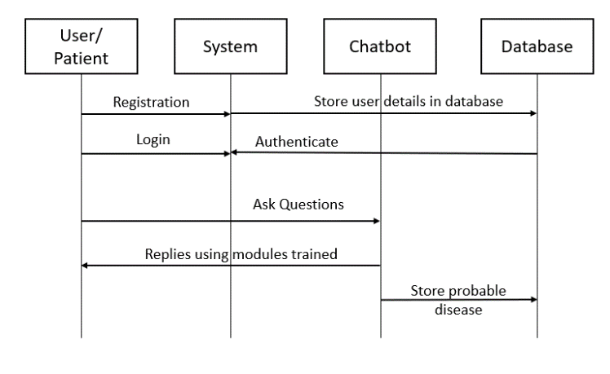
Figure: Working of Chatbot

Working of the System:

Registration/ Login
The users using the chatbot for the very first time needs to register themselves by providing personal details, and login credentials to login in future. All the details of the user are stored in MySQL database. The users who have already registered them just need to enter their correct login credentials to use the system. The system will then check the login credentials with that that of present in the MySQL database. If the credentials are correct then the system will redirect the user to chatbot else it will show an error. [12]

Medical Chatbot
The user gets the access to medical chatbot, which is trained using a TensorFlow and Keras. TensorFlow is an open-source library available free of cost. It is basically used to implement machine learning and artificial intelligence. The medical chatbot contains two major phases namely symptom extraction and diagnosis which is based on the symptoms. In the first phase, the system enters the loop to get the details of symptoms faced by the user. The system then replies to the user using different modules in which it is trained. Therefore, the system shows the probable health issue a user may be facing.

Doctor Suggestion
Based on the outcome i.e., a probable disease a user might be facing, some websites (where doctors come for online check-ups) will be recommended to the user, which enables the user to contact the doctors for consultation.

Previous Record
The medical chatbot after showing the preliminary diagnosis to the user, saves the probable disease in a database. A user can view it anytime he/she wants to. This can also be helpful while consulting a doctor.

METHODOLGY USED

Natural Language Processing:

The extension of NLP function is quite tough because all the computer systems need humans to interact with them in a certain programming language. But human language contains a lot of composite variables which makes it very less accurate. To solve this problem, NLP is used by computers to analyze, understand, and derive meaning from human language in a useful way [13]. Therefore, NLP permits a user to ask queries from the system. By using NLP, system understands important elements from user’s text that can be related to information in a dataset and thus provides with an answer. The stored information in the datasets include greeting messages, user’s details and symptoms related to a particular disease on the basis of which we predict the disease.

To implement Natural Language Processing, most commonly Natural Language Toolkit (NLTK) is used. NLTK is an open-source library for python programming language that work with human language data. Some steps to implement NLP in chatbot –

a. Tokenization: NLTK divides the large quantity of text into words called tokens. This is the base step to implement NLP. These tokens are further used to match the pattern.
Example- “I am feeling feverish” is divided into [‘I’, ‘am’, ‘feeling, ‘feverish’]

b. Lemmatization: It is the process in which words (tokens made in tokenization) are converted to its meaningful base forms. In this chatbot, we have used wordnet lemmatizer. [11]
Wordnet is a large and freely available lexical database for English language.
Example – Tokens made above will be converted as [‘feel’, ‘fever’]

c. Pattern Matching: After all the words are lemmatized, the symptoms are matched with the information present in the dataset and accordingly output is generated and stored.

This concludes the creation of training data in our chatbot. To further implement our chatbot, we created models using Keras.

Keras:
It is basically an open-source library that provides an interface for both artificial neural networks (Used in deep learning) in python and TensorFlow library. [14,15] To implement the chatbot, we made models, defined different layers and optimizer. Therefore, Keras compiles our model with optimizer functions and training process with fit function. [16] The implementation of the said is done in the following steps:

a) Create model -

We create a model of 3 layers to implement the chatbot. First layer is of 128 neurons, second layer is of 64 neurons and the third which is also the last layer contains the number of neurons which is equal to the number of intents to produce output intent. The first and the second layer is activated using Rectified Linear Unit (ReLu) which returns 0 in case of negative input and returns value itself if it is a positive input [9]. The third layer is activated using softmax which converts a vector of values to a probability distribution. This makes it easier to interpret the result on basis of their probability. [10]

b) Compile model –

We have used Stochastic Gradient Descent (SGD) as an optimizer in the chatbot. Keras provides SGD class that implements stochastic gradient descent optimizer with a learning rate and momentum. In this chatbot, we have applied learning rate as 0.01, momentum as 0.9 and decay rate as 1e-6 (0.000001).
To compile the model, we have used categorical cross entropy loss function which is used to evaluate the quantity that the model should seek to minimize during the training part. Since we have converted the values to a probability distribution while creating a model, the best loss function to use is categorical cross entropy. Mathematical formula for cross entropy –

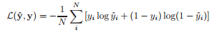
Mathematical formula to calculate cross entropy

c) Fitting and saving model –

For fitting the model, we have used 200 epochs. An epoch is basically an iteration over the entire data. We have also specified batch size as 5 which means that 5 samples are taken per gradient update. Verbosity mode is also given as 1 which includes both progress bar and one line per epoch.

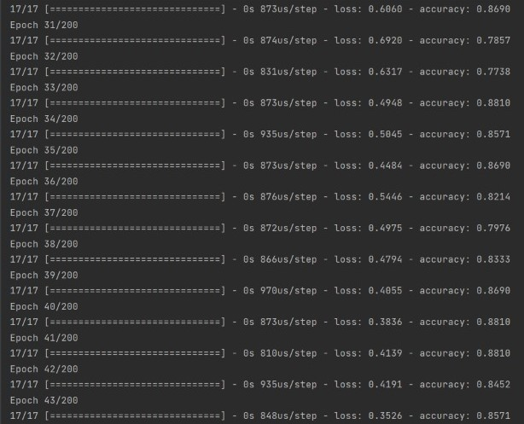
Progress line per epoch

This is the screenshot of the system training the project to work properly, so that it can interact with humans easily.

To validate the working of the model, Term Detection Test by General Word Percentage approach is used.

By using General Word Percentage approach, we can get a ratio of number of unrelated words used over the total number of words in a particular message. [17] This approach helps us to understand about how our Chatbot could deal with unrelated words that are mixed with medical terminologies. We would take some sample corpus to proceed with the analysis. We would check whether our Chatbot is able to detect medical terminologies for our sample corpus.

Sample corpus for analysis:
1. Hey Chatbot! I am not able to handle this headache and I feel like vomiting. My digestion is also not okay and feeling lazy.
2. Can we cure brain cancer? I think I am suffering from it.
3. I think I have cancer. I also feel like vomiting since yesterday. I want medicines for typhoid.
4. I am feeling good today! But I am having a headache.
5. I am feeling like nausea since yesterday.

Corpus No. | GWP Ratio | Terms Present | Terms Detected | Term Detection Ratio
1 | 0.833 | 4 | 3 | 0.75
2 | 0.916 | 1 | 0 | 0.00
3 | 0.823 | 3 | 3 | 1.00
4 | 0.909 | 1 | 2 | 0.50
5 | 0.857 | 1 | 1 | 1.00
Average | 0.867 | 2 | 1.8 | 0.65
Table: Illustrating Term Detection Ratio

Calculations Taken:
GWP Ratio – Number of unrelated medical terms/ Number of total words in corpus
Term Detection Ratio – Terms Detected/ Terms Present

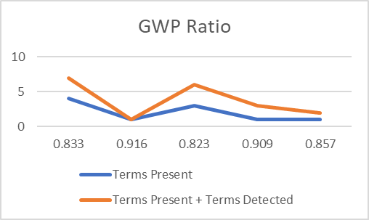
Figure: Visual Representation of GWP Ratio

We notice that with an average 86.7% of the unrelated terms present in our sample corpus, our Chatbot performed Terminology detection with 65% of accuracy. We can observe through the above table (Table 2) and Figure 1 that with the decrease in GWP ratio and the increase in the terms present in a message, our Chatbot performed efficiently and was successfully able to detect correct medical terminologies from the corpus. However, the efficiency of terminology detection would also depend on the way users type and preciseness of the messages.

RESULT AND DICUSSION

This area furnishes with the aftereffects of the thorough experimentation of the created system. The proposed framework is a proficient, modest, simple and a speedy method to assist patients with having a coordinated discussion with the Chatbot that encourages and helps them to deal with their wellbeing adequately. Following are the screenshots of the system:

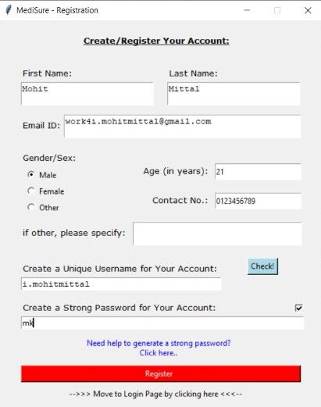
Figure: Registration Page

Above screenshot is about the registration page interface, in which user can create his account in order to login to the software. Every new user has to create his account because in medical receipt, there are few things that should be mentioned and all those information will be taken from the database that we created.

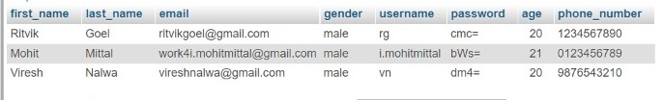

Figure: SQL database that stores data of user

This is the localhost database list of users that we created in our system. All the user's information here will be shown in the main interface after login.

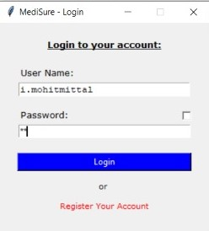
Figure: Login Page

This is the login page interface, in which a user can login. The password here is in hidden format but, we can see the password by clicking the check box. Also, if a user hasn't registered and their entry is not in the database, they can't login.

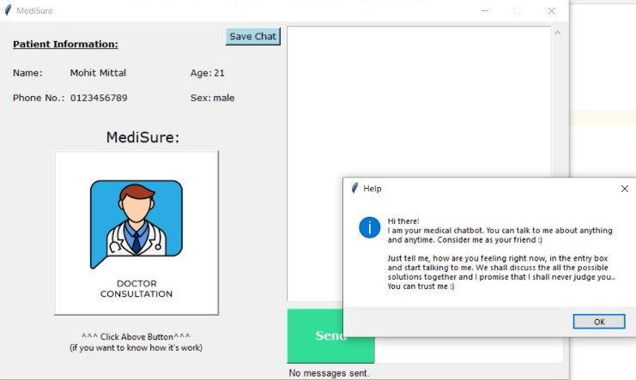

Figure: Chatbot Main Page

This is the main chat interface here. All the information of the user (who login) is showing up here. The doctor's image in the interface, is actually a help button. By clicking the image, a dialogue box will pop up, in which message is written.

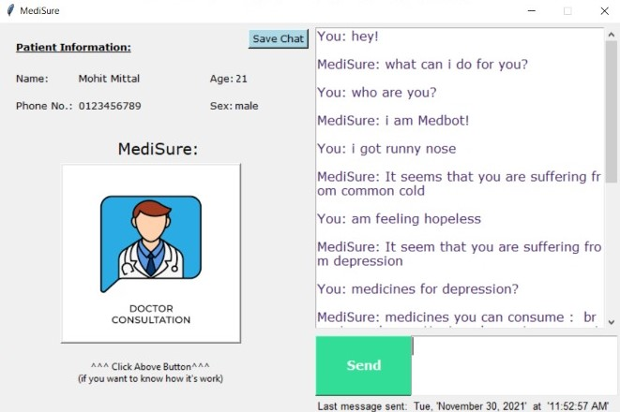

Figure: Interaction with Chatbot

On the right side, there's a chat interface in which user can chat with the system. He can ask questions related to his health and system will reply. Also, "Date and Time" will be shown like, when the last message has been sent.

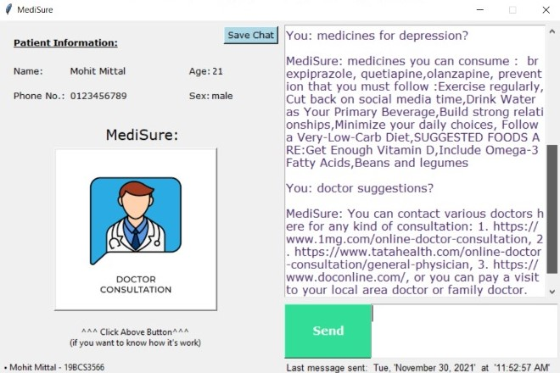

Figure: Interaction with Chatbot Cont.

In this screenshot, user is asking for the medicines and doctor suggestions as he discussed his health above. And, system is telling him about some medicines he can consume and suggested some doctors.

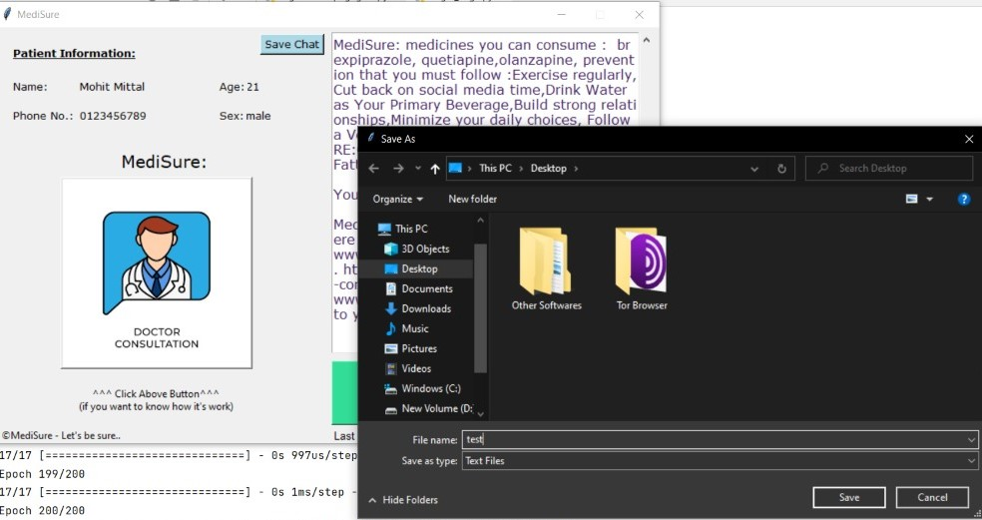

Figure: Option to save chat

We can save all the chats done between user and the system by clicking the save button. We just have to provide a location to save the file and name of the file. Also, we can give any extension to the file except of .txt format.

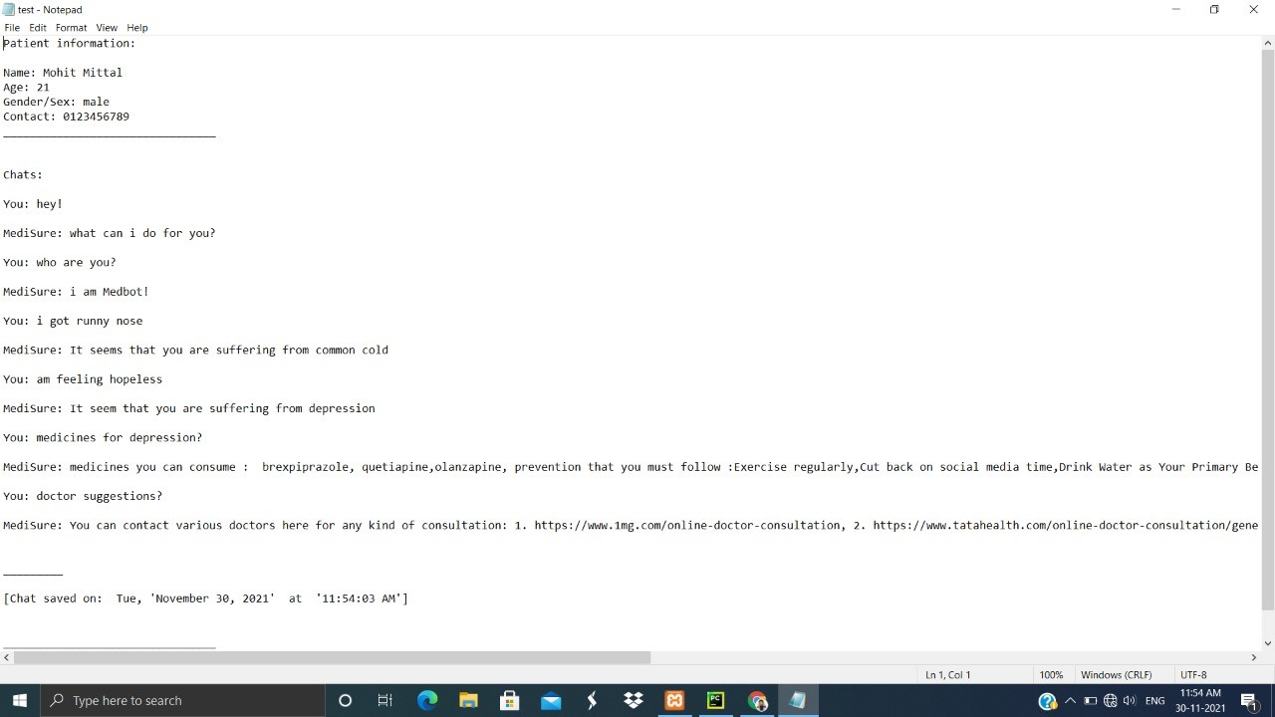

Figure: Saved chat in .txt file

This is the file that we saved. This file is saved in .txt format. Also, the information of the patient is already mentioned in this file. All the chats done between system and the user is here, with date and time.

CONCLUSION

In this paper, we have implemented a system for the patients which will have great impact in their life. It would provide the users an advantage of carrying virtual doctor with them. It would also give them a freedom to check the current status of their health 24/7. This can turn out to be one of the most popular tools among the people having a busy schedule. This system can also be useful to the elderly and physically disabled people as they can get information about their minor health issues at their fingertips. The implemented system also provides an option to download the results generated by chatbot which can be further used when consulting a doctor. The users can also take advantage of this application as all the data is kept online and therefore provides a real time experience to them.

FUTURE SCOPE

For advancement of the implemented system, we can bring doctors and medical professionals to this platform to whom can users consult according to the disease diagnosed by the chatbot. Bringing them on the platform will increase the efficiency and accuracy of the system.
We can also implement the system into android or iOS so that the users can use the system more conveniently and also it will make this tool reachable to every user.
The medical details of the user are very confidential and should not be disclosed to anyone. So, the database containing information about the medical and personal details of the user can be encrypted so no one can view/modify them.
To reduce the difficulty of sending text messages to a chatbot, we can add voice assistant in the system which will make it easier to use.

References

- Krishnendu Rarhi, Abhishek Mishra and Krishnasis Mandal , “Automated Medical Chatbot” in SSRN Elecronic Journal, 2017.
- Mrs. Asha Rani K P, Mrs. Asha K N, Ranjith Kumar D R, Rohan, Ranjan Raj and Rohini, “Medical Chatbot for Disease Prediction using Machine Learning”, IJARESM, vol. 9, 2021
- S. Anil Kumar, C. Vamsi Krishna, P. Nikhila Reddy, B. Rohith Kumar Reddy and I. Jeena Jacob, “Self-Diagnosing Health Care Chatbot using Machine Learning”, IJAST, vol. 29, 2020.
- Gajendra Prasad K. C., Satvik Ranjan, Tathagat Ankit, and Vivek Kumar, “A Personalized Medical Assistant Chatbot: MediBot”, IJSTE, vol. 5, 2019.
- Dr. Paul Raj, Murali Krishna R, Solleti Manoj Krishna, Koppolu Harsha Vardhan, and Kameswara Rao M, “EMERGENCY PATIENT CARE SYSTEM USING CHATBOT”, IJTRE, vol.6, 2019.
- Monica Agrawal, Janette Cheng and Caelin Tran, “What’s Up, Doc? A Medical Diagnosis Bot”,.
- Deepmala Kale and Shailendra Aswale, “Doctor Chatbot: Heart Disease Prediction System”, ITEE, vol.9, 2020.
- Prof. Dhomse Kanchan B. and Mr. Mahale Kishor M, “Study of Machine Learning Algorithms for Special Disease Prediction using Principal of Component Analysis”, International Conference on Global Trends in Signal Processing, Information Computing and Communication, 2016.
- Abien Fred M. Agarap, “Deep Learning using Rectified Linear Units (ReLU)”, cs.NE, Feb 2019
- Chigozie Enyinna Nwankpa, Winifred Ijomah, Anthony Gachagan, and Stephen Marshall, “Activation Functions: Comparison of Trends in Practice and Research for Deep Learning”, Nov 2018
- Divya Khyani , Siddhartha B S , Niveditha N M ,Divya B M, “An Interpretation of Lemmatization and Stemming in Natural Language Processing”, Journal of University of Shanghai for Science and Technology, 2021
- Shweta J. Patil, “Python – Using Database and SQL”, International Journal of Science and Research, 2019
- Diksha Khurana , Aditya Koli , Kiran Khatter and Sukhdev Singh, “Natural Language Processing: State of The Art, Current Trends and Challenges”, ResearchGate, 2017
- Mart´ın Abadi, Paul Barham, Jianmin Chen, Zhifeng Chen, Andy Davis, Jeffrey Dean, Matthieu Devin, Sanjay Ghemawat, Geoffrey Irving, Michael Isard, Manjunath Kudlur, Josh Levenberg, Rajat Monga, Sherry Moore, Derek G. Murray, Benoit Steiner, Paul Tucker, Vijay Vasudevan, Pete Warden, Martin Wicke, Yuan Yu, and Xiaoqiang Zheng, “TensorFlow: A system for large-scale machine learning”, ResearchGate, May 2016
- Ms. Sonali. B. Maind, Ms. Priyanka Wankar, “Research Paper on Basic of Artificial Neural Network”, International Journal on Recent and Innovation Trends in Computing and Communication, vol 2, issue 1.
- Karan Jakhar, Nishtha Hooda, “Big Data Deep Learning Framework using Keras: A Case Study of Pneumonia Prediction”, 4 th International Conference on Computing Communication and Automation, 2018
- Denoyer L., Gallinari P. (2007) The Wikipedia XML Corpus. In: Fuhr N., Lalmas M., Trotman A. (eds) Comparative Evaluation of XML Information Retrieval Systems. INEX 2006. Lecture Notes in Computer Science, vol 4518. Springer, Berlin, Heidelberg

